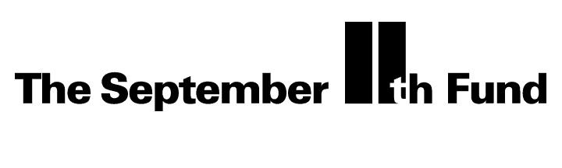

Administrative Revenue and Expenses

Funds provided: $2,600,000
Est. interest: $540,000

Total available: $3,140,000

Expenses since $2,286,014
Inception (through 2/03)

Amount remaining: $853,986

